JSTOR interactive research tool social media kit
How to use this kit
Suggested social media copy (adapt as needed)
Image credits

How to use this kit
Dear librarians, faculty, partners, and institutional leaders,

We are excited to provide suggested social media copy and graphics to help you promote JSTOR’s interactive research tool within your community. Accompanying graphics can be found here. This tool streamlines research by offering targeted content searches and surfacing key points–ideal for students, faculty, and librarians.

Feel free to share the provided content across social media, newsletters, or other channels to raise awareness and encourage use of this valuable resource.

Thank you for your support in making research more efficient and accessible for all.

Sincerely,
The JSTOR Team

P.S. Tag JSTOR in your posts and we’ll amplify your messages across our social media channels!

- LinkedIn: @JSTOR
- Facebook: @JSTOR.org
- Instagram: @JSTOR_org
- X (formerly Twitter): @JSTOR
- Threads: @JSTOR_org

Suggested social media copy (adapt as needed)
Unlock smarter research with JSTOR’s interactive research tool. 🧠 Whether you’re a student, faculty, or librarian, the tool helps you find relevant sources quickly, making research more focused and fruitful. With time saved on searching, you can spend more energy analyzing and applying what matters most. ➡️ Learn more here: https://about.jstor.org/research-tool/, or login to your JSTOR account and start using the tool today!

Avoid spending hours reading the wrong sources with JSTOR’s interactive research tool. 🚫 Use the tool to screen academic resources based on topics, keywords, and themes to get connected to the RIGHT content faster. Whether conducting a deep dive or just gathering preliminary materials, you’ll have more time to focus on what matters. ☄️ Learn more here: https://about.jstor.org/research-tool/, or login to your JSTOR account and start using the tool today!

JSTOR’s interactive research tool is designed for those who value quality research. 🎓 Perfect for students, faculty, and librarians, it offers fast access to relevant content and insightful overviews. Cut down on research time and invest it where it counts–discovery, analysis, and the development of your unique point of view. 🙌🏻 Learn more here: https://about.jstor.org/research-tool/, or login to your JSTOR account and start using the tool today!

Spend less time searching and more time researching! ⏱️ JSTOR’s interactive tool connects you to relevant materials quickly, providing key points, related topics, and recommended content to optimize your workflow. ✏️ Learn more here: https://about.jstor.org/research-tool/, or login to your JSTOR account and start using the tool today!

After more than a year of beta testing, users of JSTOR’s interactive research tool are spending more time on JSTOR, not less. ⌛️ Why’s that? The tool simplifies the process of finding relevant academic resources, increasing the amount of time you can spend with the right content and your chances of developing a truly unique point of view. That’s a win-win in our book. 💥 Learn more here: https://about.jstor.org/research-tool/, or login to your JSTOR account and start using the tool today!

Get more out of your search. 🔎 Say goodbye to endless scrolling. Use JSTOR’s interactive research tool to ask questions in natural language and find exactly what you need. Perfect for students tackling complex topics! ✨ Learn more here: https://about.jstor.org/research-tool/, or login to your JSTOR account and start using the tool today!

Explore new connections. 🔗 Expand your research horizons by discovering related topics and content recommendations. Let JSTOR guide you to unexpected insights, open up new research paths, and broaden your understanding. ⚡️ Learn more here: https://about.jstor.org/research-tool/, or login to your JSTOR account and start using the tool today!

Faculty, streamline your teaching prep! 📚 Use JSTOR’s interactive research tool to quickly assess content relevance and provide students with well-suited resources for course readings and assignments. Efficiency meets quality on one platform. 🌟 Learn more here: https://about.jstor.org/research-tool/, or login to your JSTOR account and start using the tool today!

Ask questions, get answers. 💡 Got specific research questions? Just ask them directly in JSTOR’s interactive research tool and receive tailored insights instantly. Perfect for deep dives into complex topics. 💫 Learn more here: https://about.jstor.org/research-tool/, or login to your JSTOR account and start using the tool today!

Enjoy boundless exploration with JSTOR’s interactive research tool. 🌐 Discover related resources and uncover broader connections with the recommendations feature. One question can lead to countless insights. Where will your search lead you? 🔥 Learn more here: https://about.jstor.org/research-tool/, or login to your JSTOR account and start using the tool today!

Unlock your research potential. 🚀 Simplify your research sessions with key takeaways and summaries from JSTOR’s interactive tool. Spend less time searching and more time learning. 🎯 Learn more here: https://about.jstor.org/research-tool/, or login to your JSTOR account and start using the tool today!

Image credits
Feel free to use any of the graphics found here in your promotions, with their corresponding citations:

Image | Image credit
 | Odra Noel. Mitochondria at Work. Wellcome Collection.
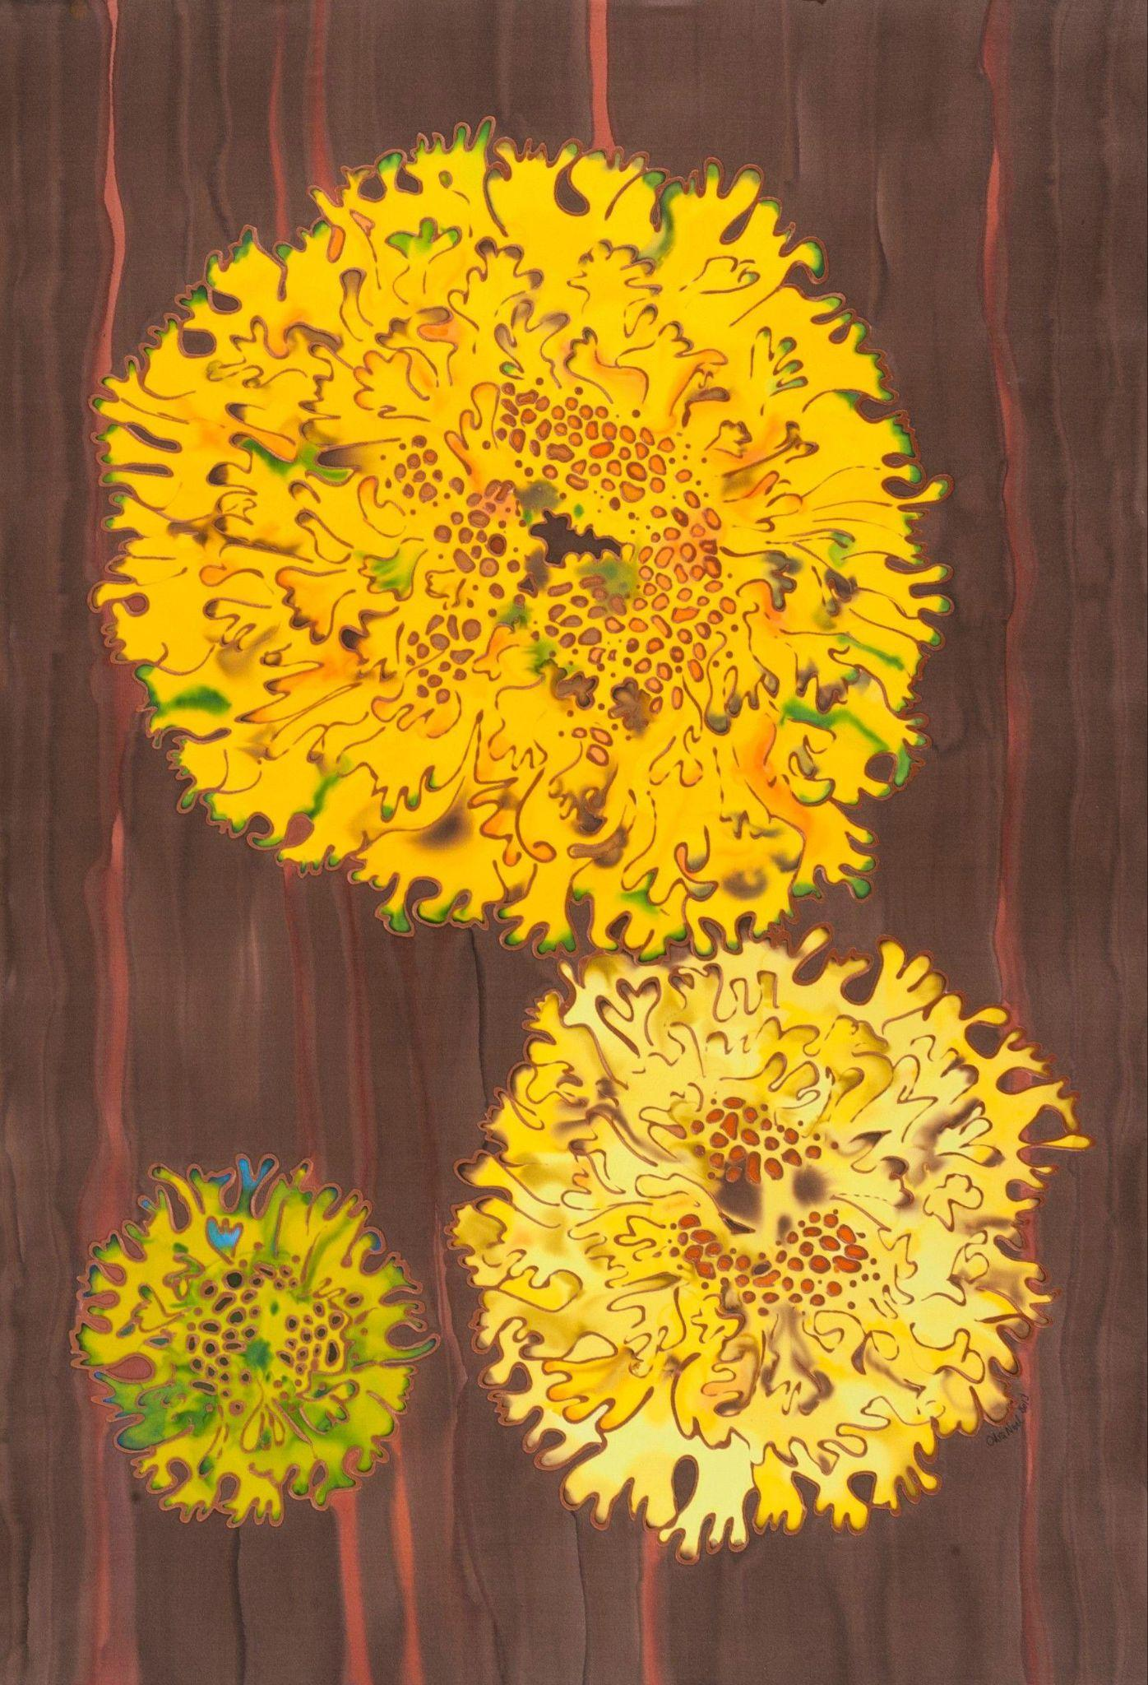 | Odra Noel. Yellow Lichen in Yew Tree. Wellcome Collection.
 | Odra Noel. Mitochondrial Permeability Transition Pore “North Passage.” Wellcome Collection.
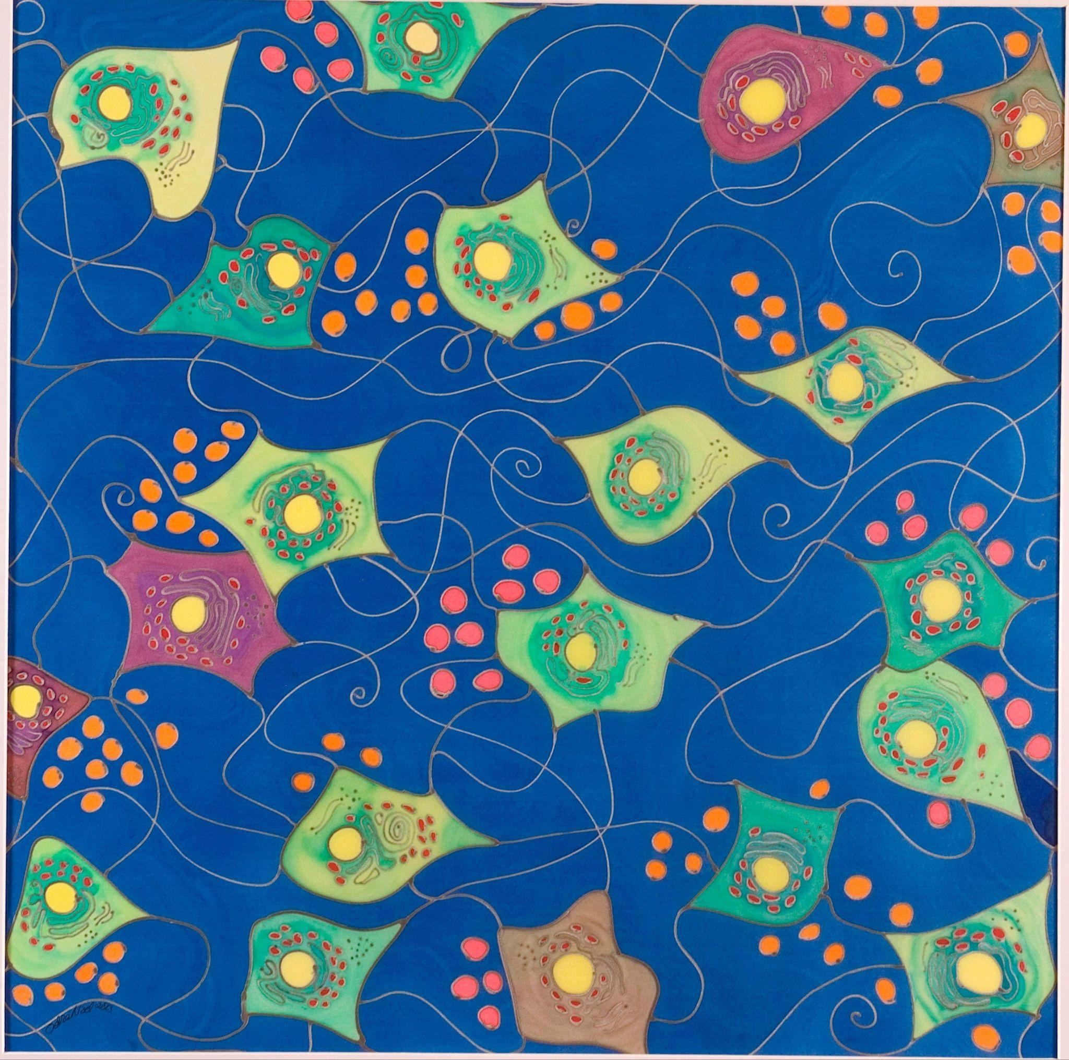 | Odra Noel. “The Neuronal Forest” Neurons.Wellcome Collection.
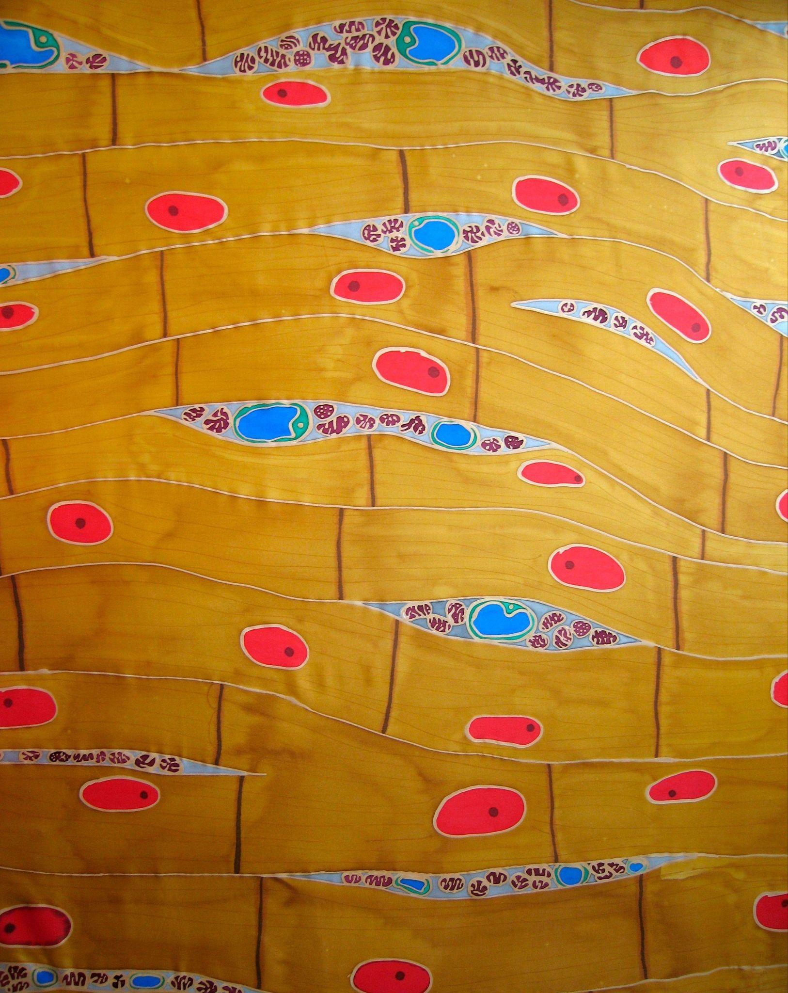 | Odra Noel. Cardiac Muscle. Wellcome Collection.
 | Odra Noel. Banded Iron Formations (BIFs). Wellcome Collection.
 | Odra Noel. Future element. Wellcome Collection.
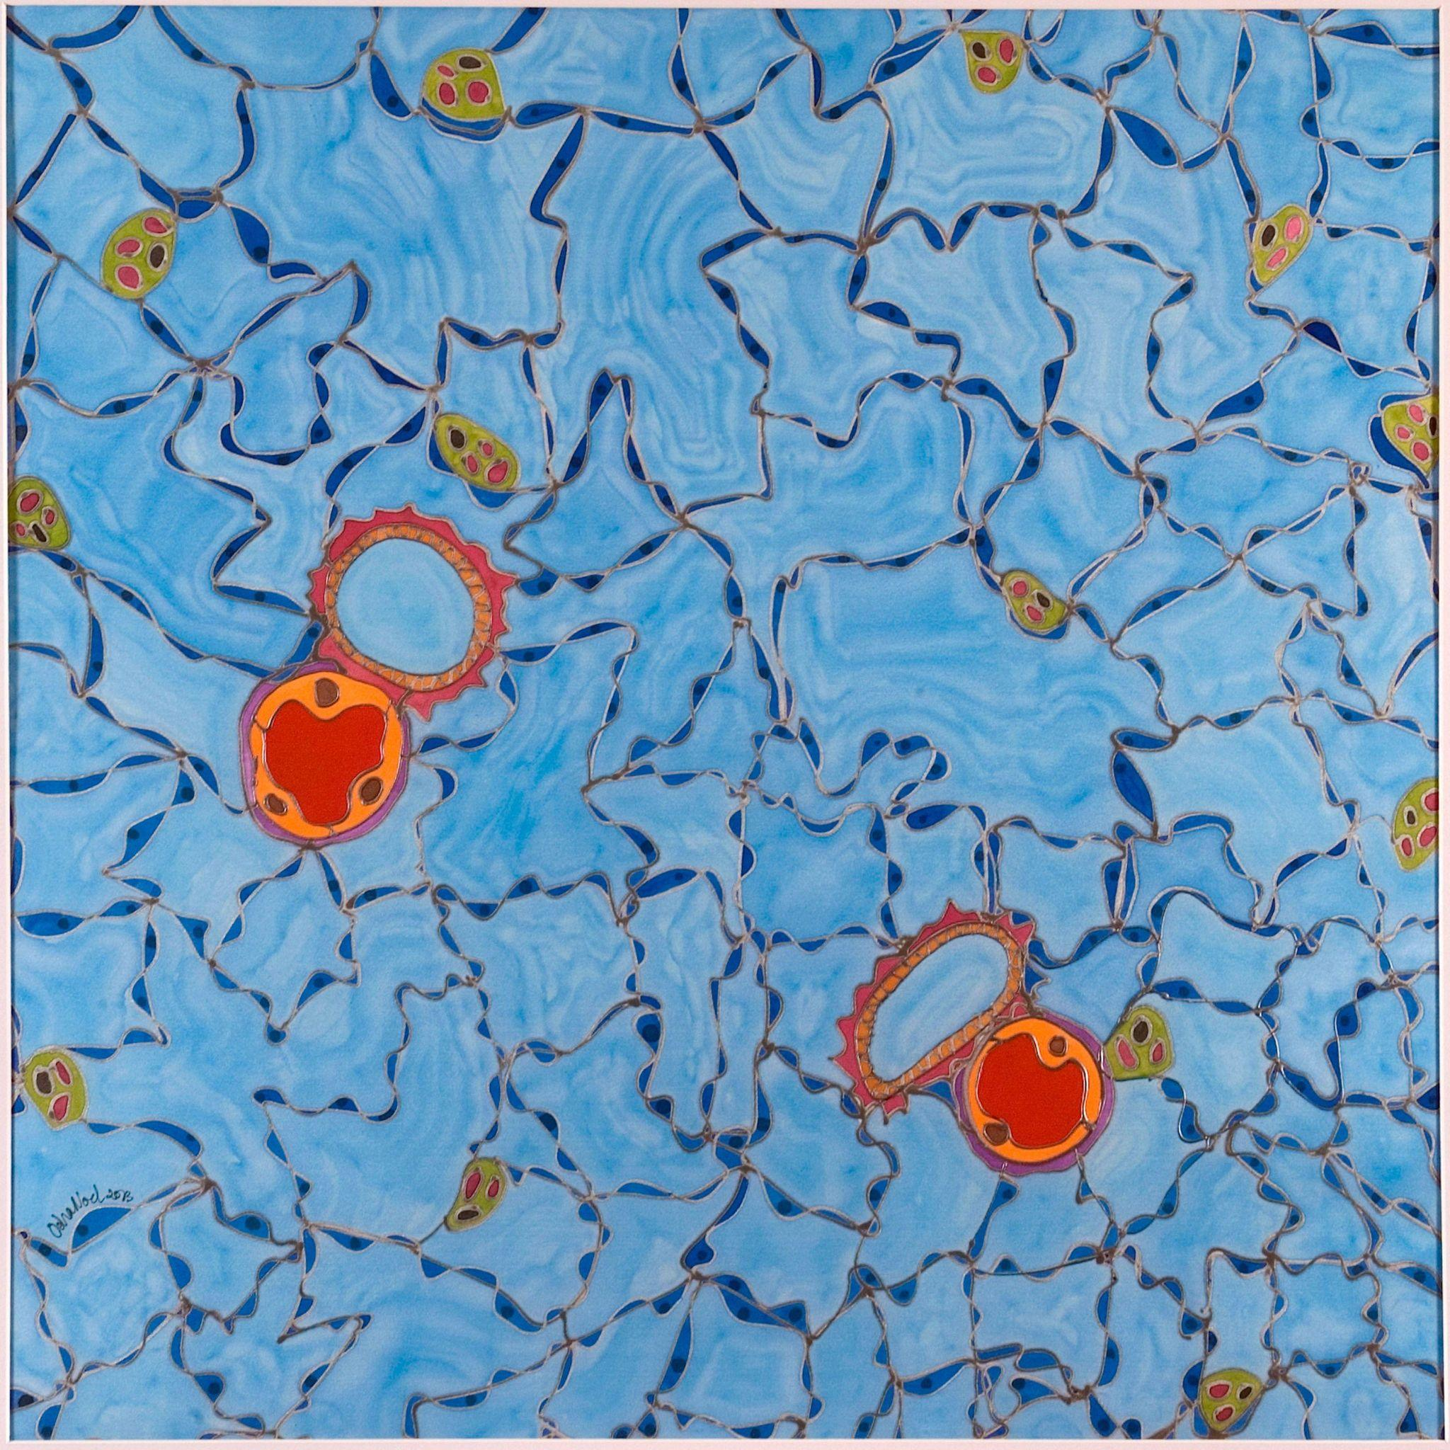 | Odra Noel. Deep breath - Respiratory tissue. Wellcome Collection.
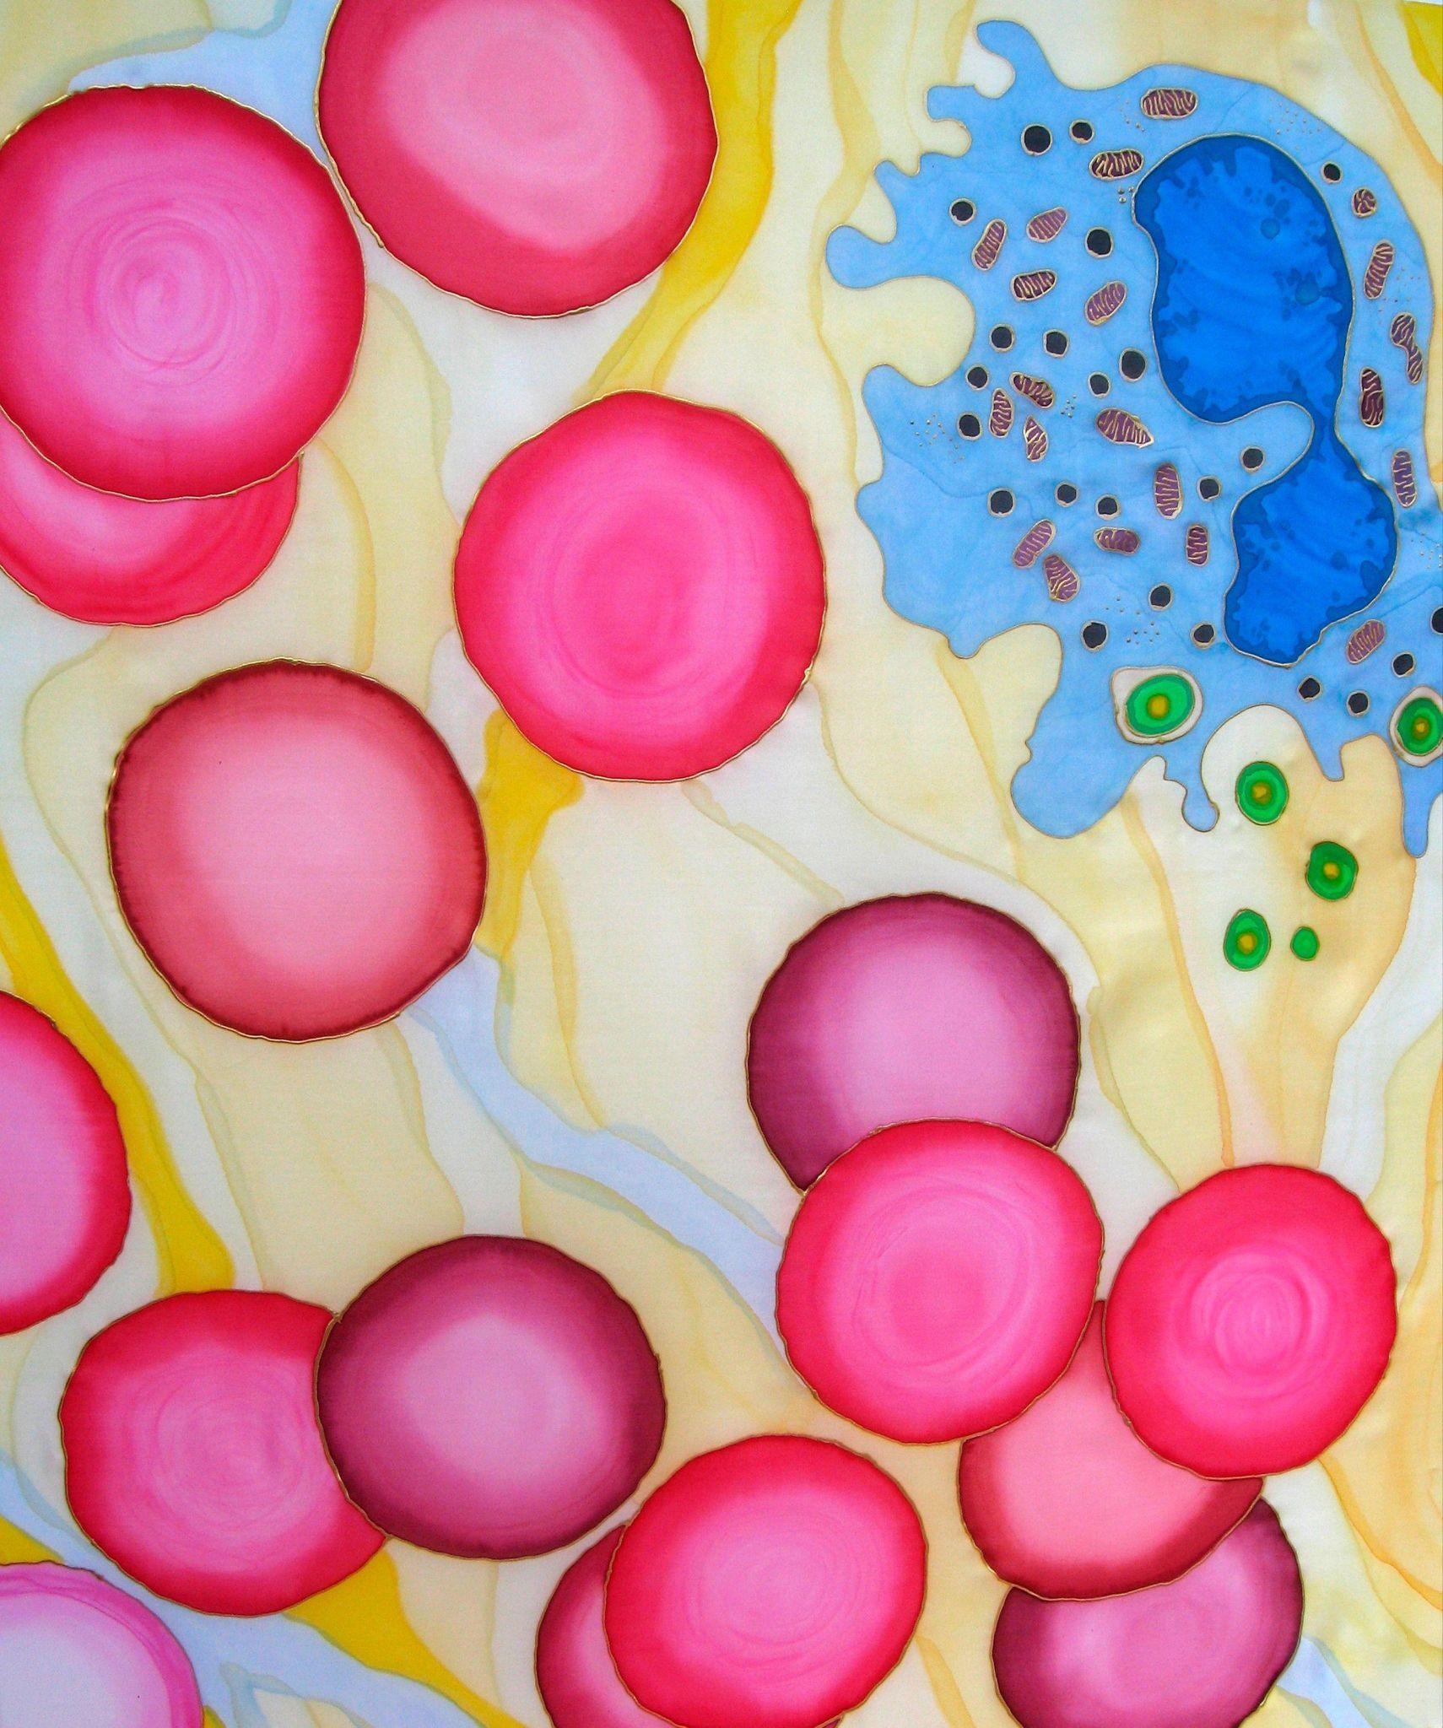 | Odra Noel. Blood cells through the microscope. Wellcome Collection.
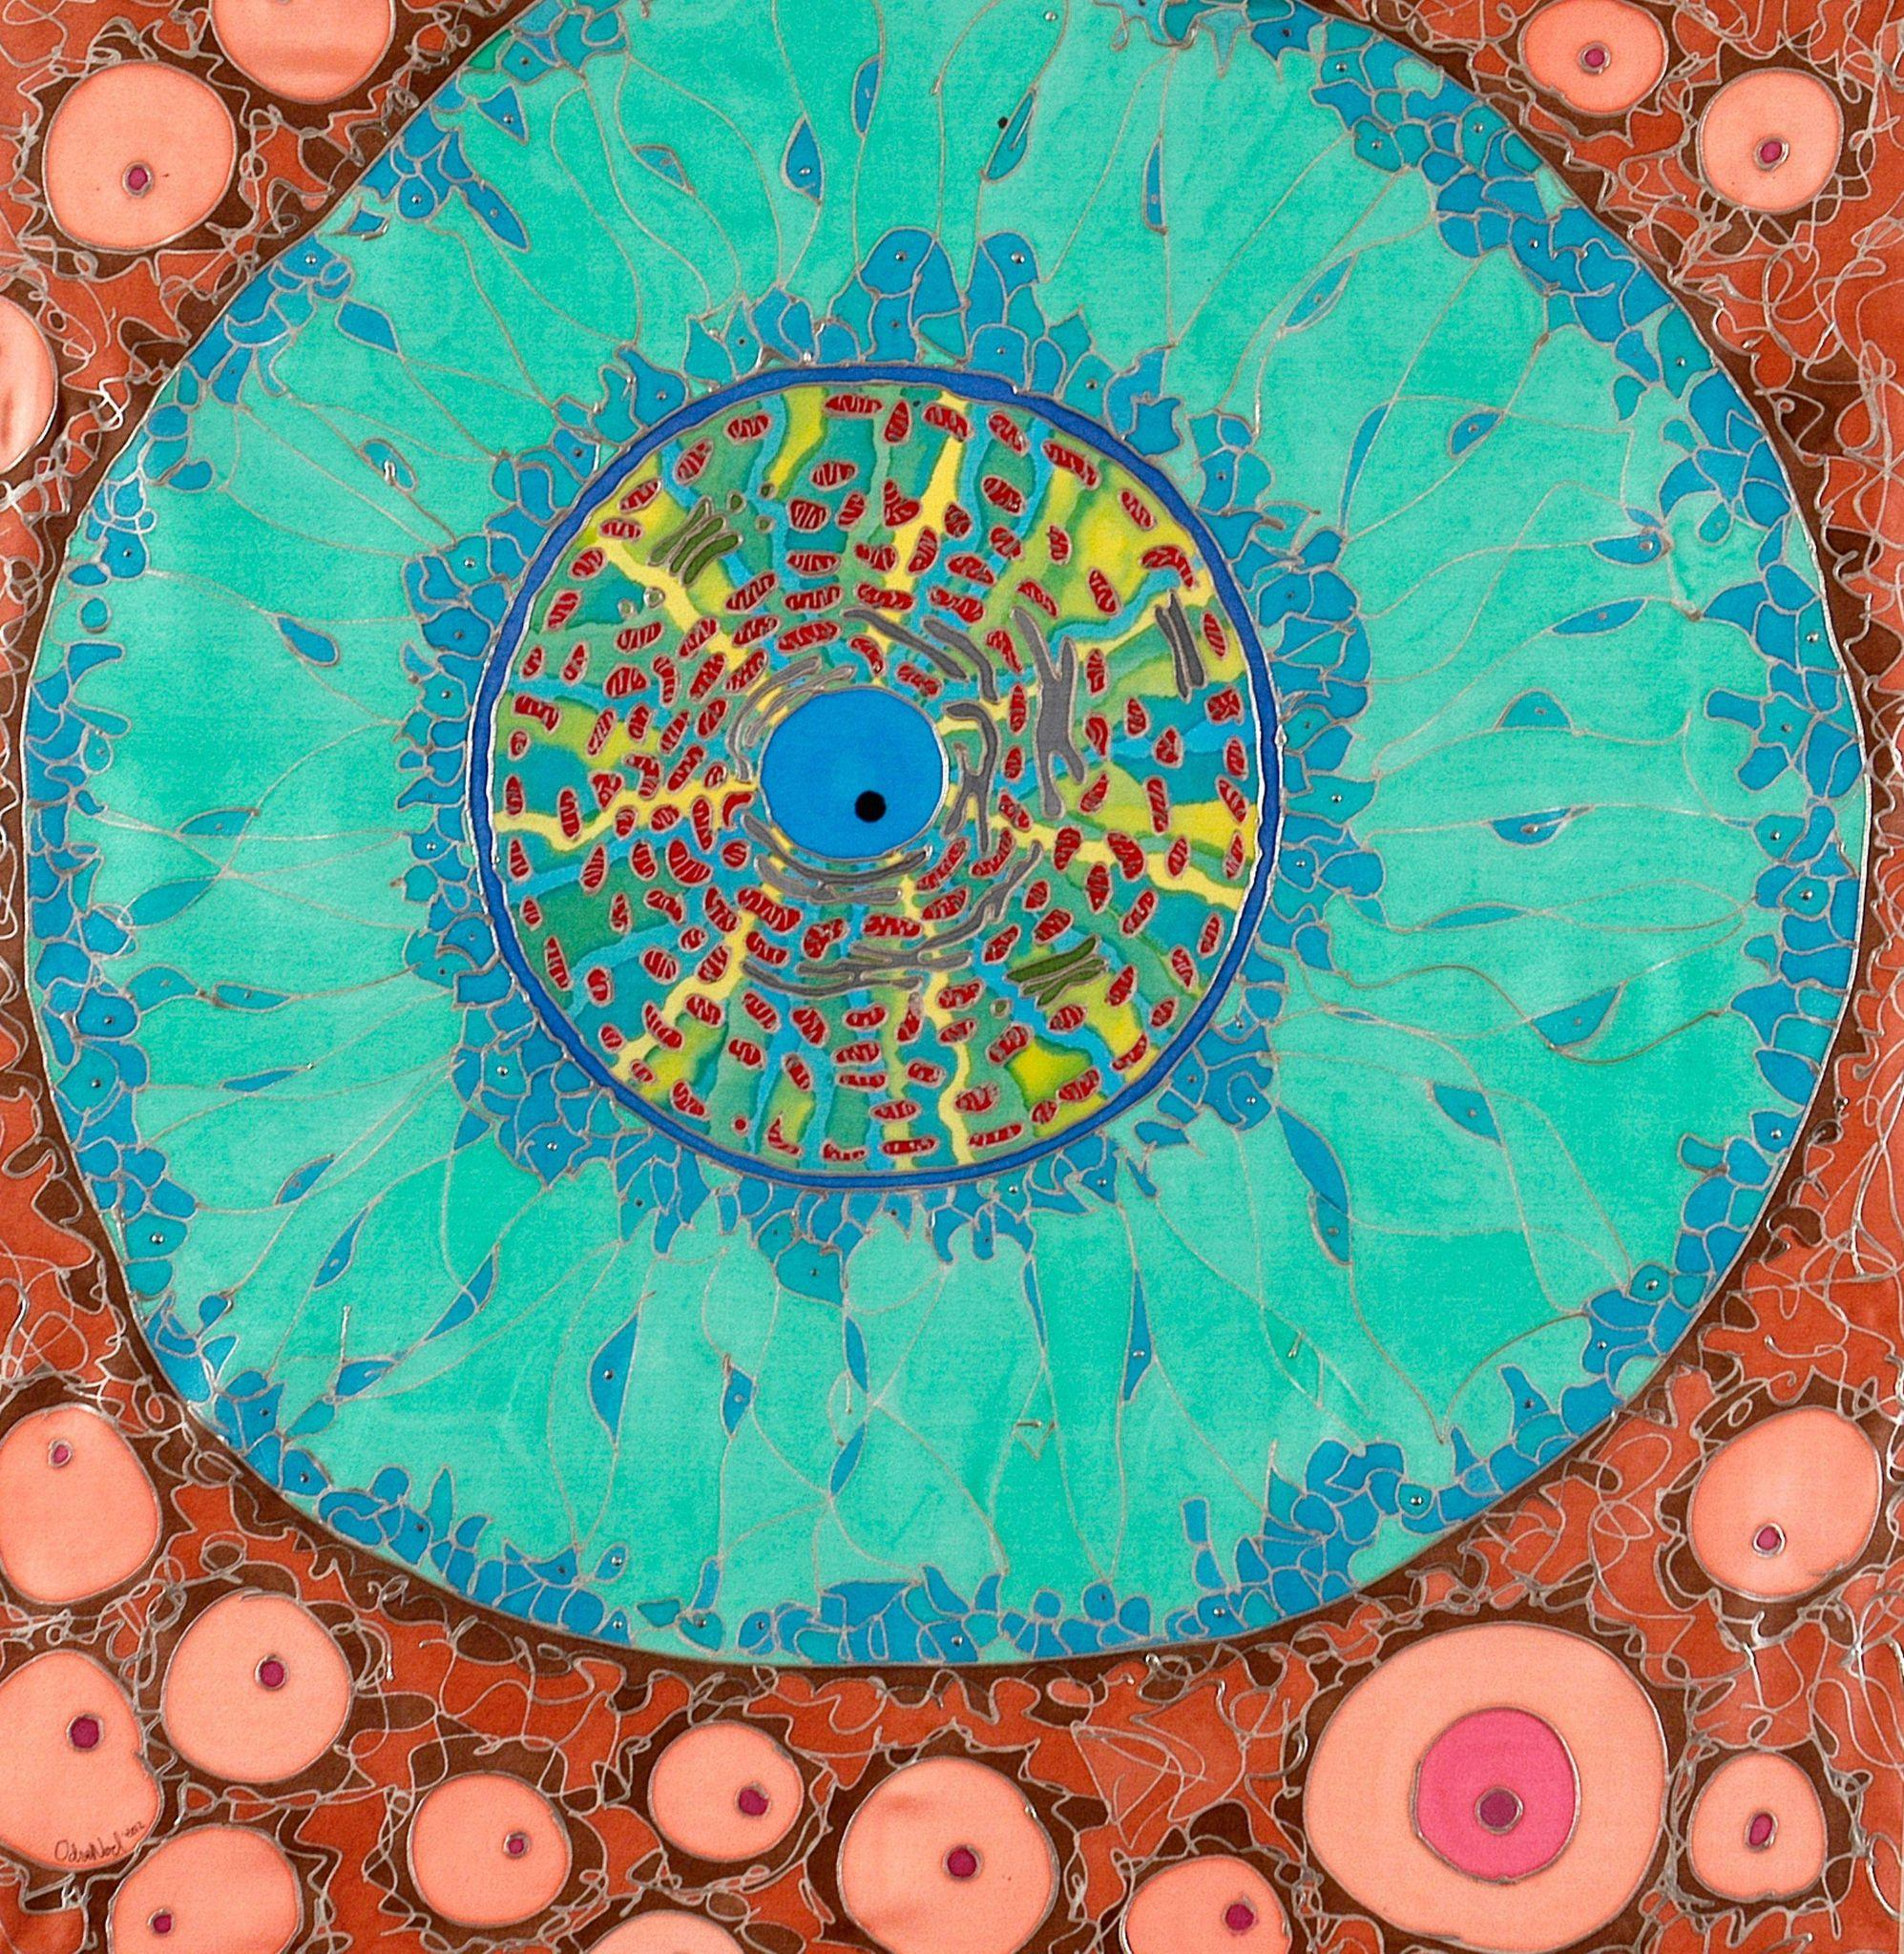 | Odra Noel. Future element. Wellcome Collection.

