Image credits for benefit-focused social media graphics

Image | Image credit
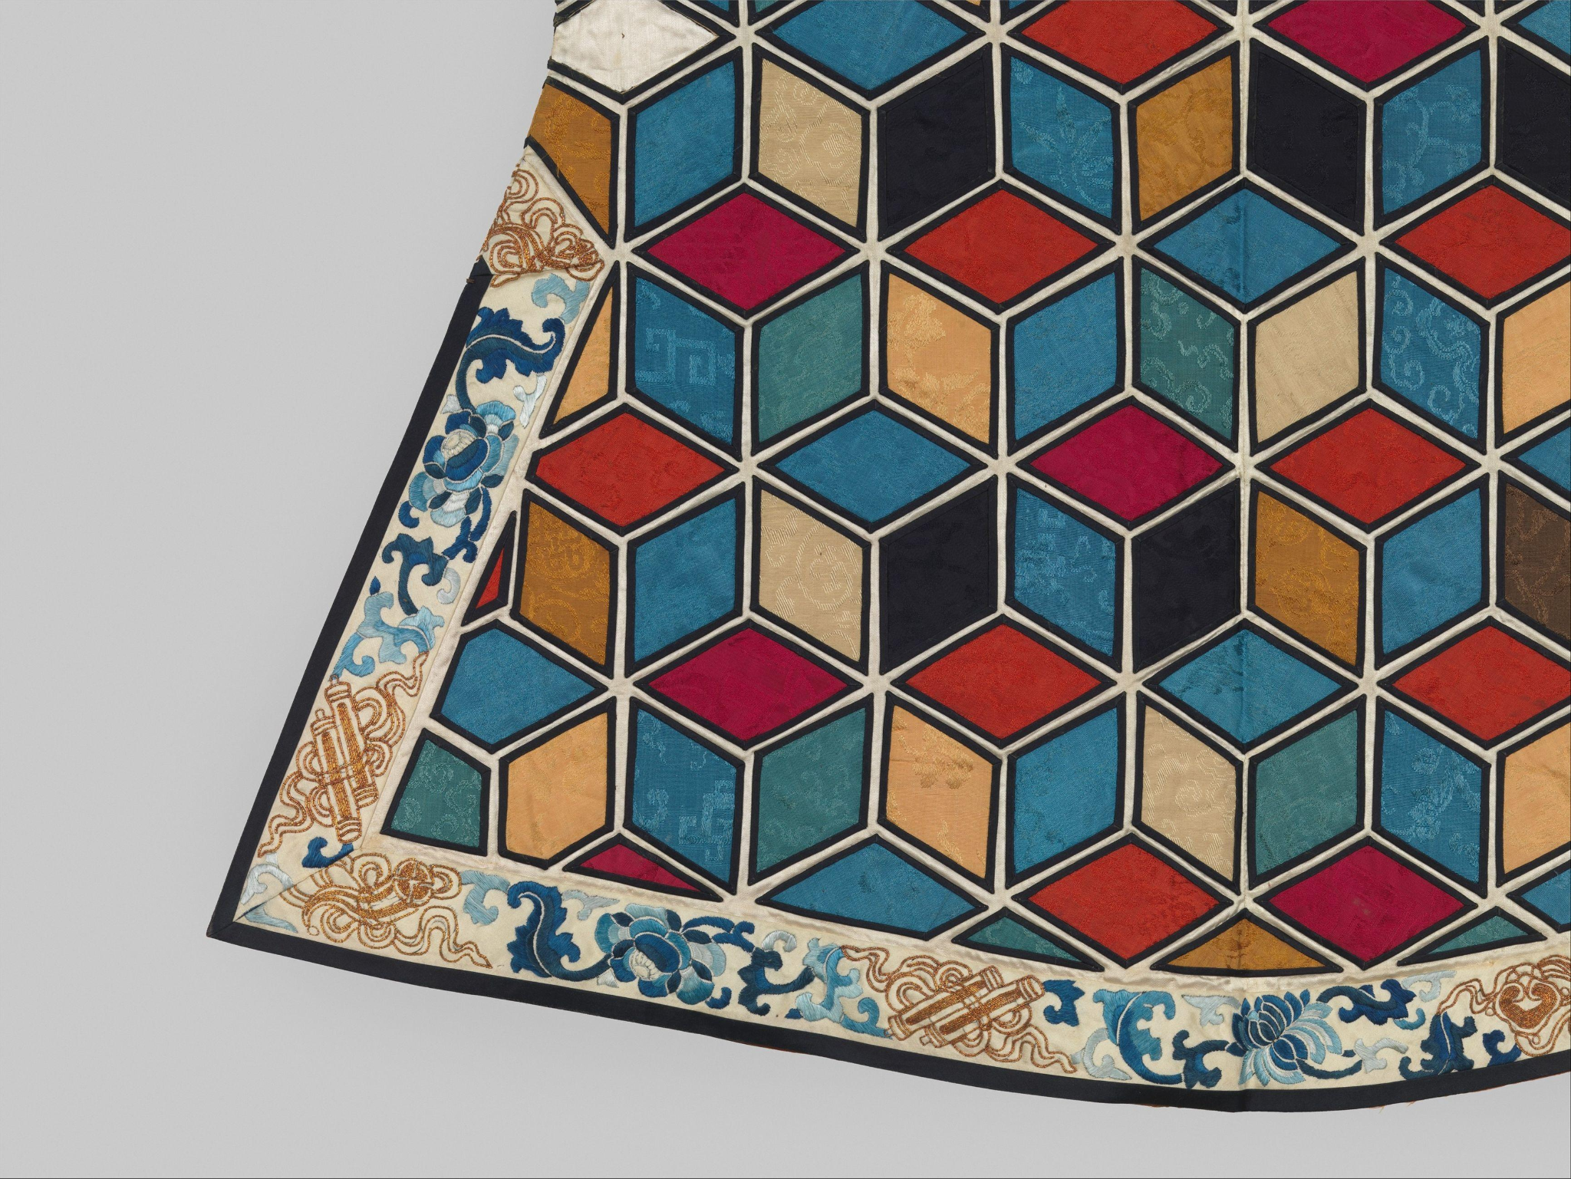 | Chinese. Woman’s Theatrical Jacket. 19th century. The Metropolitan Museum of Art.
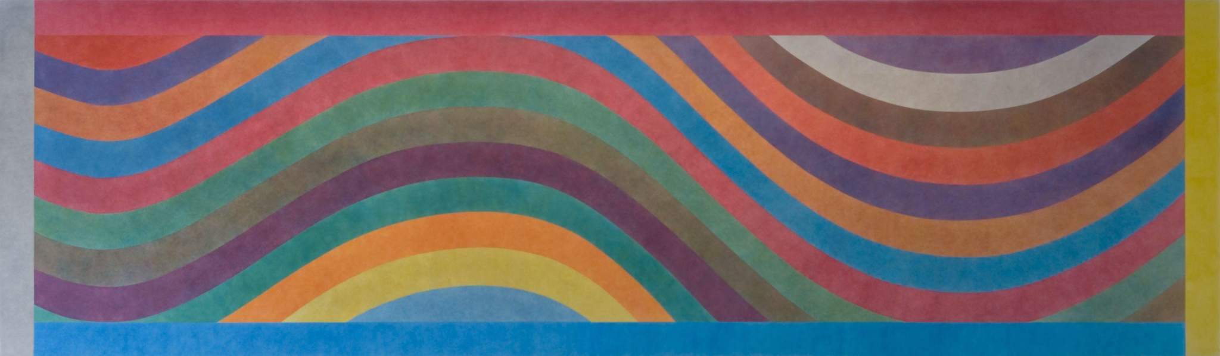 | Sol LeWitt. Wall Drawing #803-Wavy Color Bands Within a Grey, Red, Yellow and Blue Border. 1996; redrawn 2007. Colby College Museum of Art.
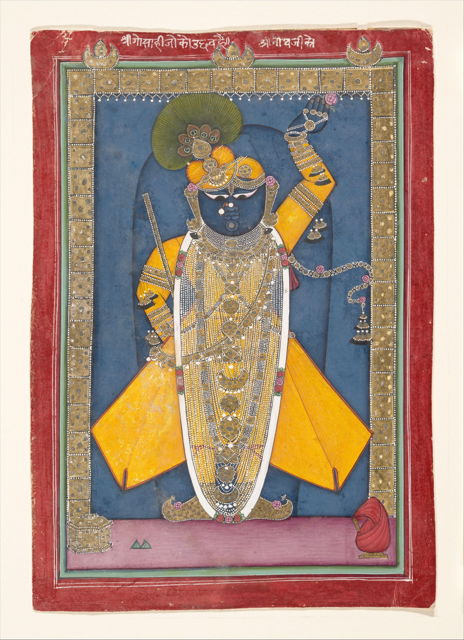 | Indian. Krishna in the Form of Shri Nathji. ca. 1840. The Metropolitan Museum of Art.
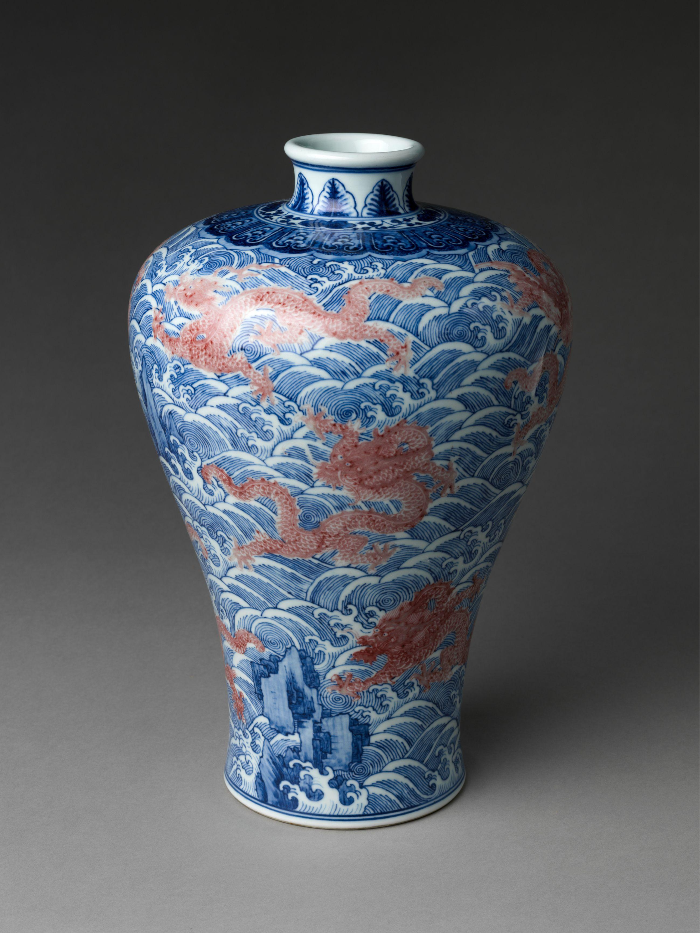 | Chinese. Meiping Vase with Dragons amid Waves. Mid-18th century. The Metropolitan Museum of Art.
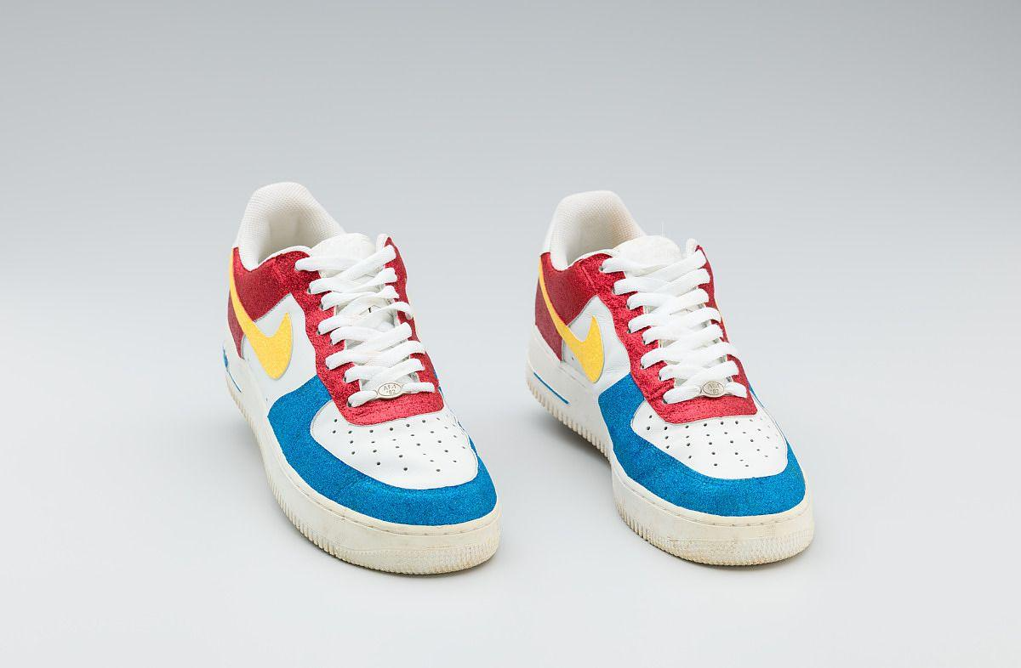 | Manufactured by Nike Inc. Red, White, Yellow, and Blue Nike Sneakers Worn by Big Boi of Outkast. 2005-2006. National Museum of African American History and Culture.
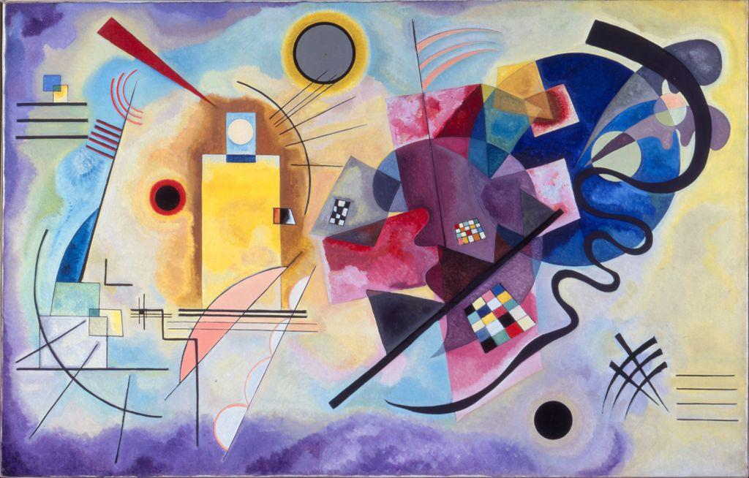 | Vassily Kandinsky. Yellow-Red-Blue (Gelb-Rot-Blau; Jaune-Rouge-Bleu). March-May 1925. Musée National d’Art Moderne, Centre Georges Pompidou.
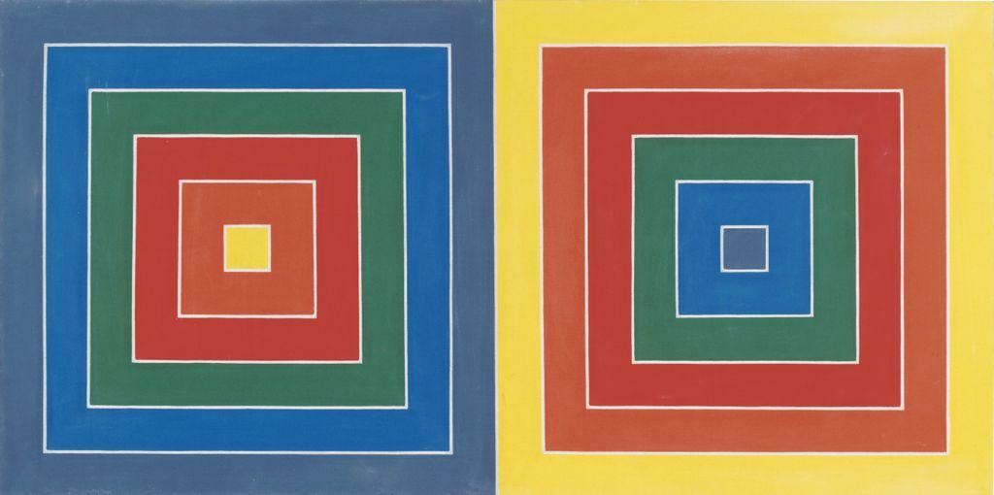 | Frank Stella. Newburyport. 1962. Yale University Art Gallery.
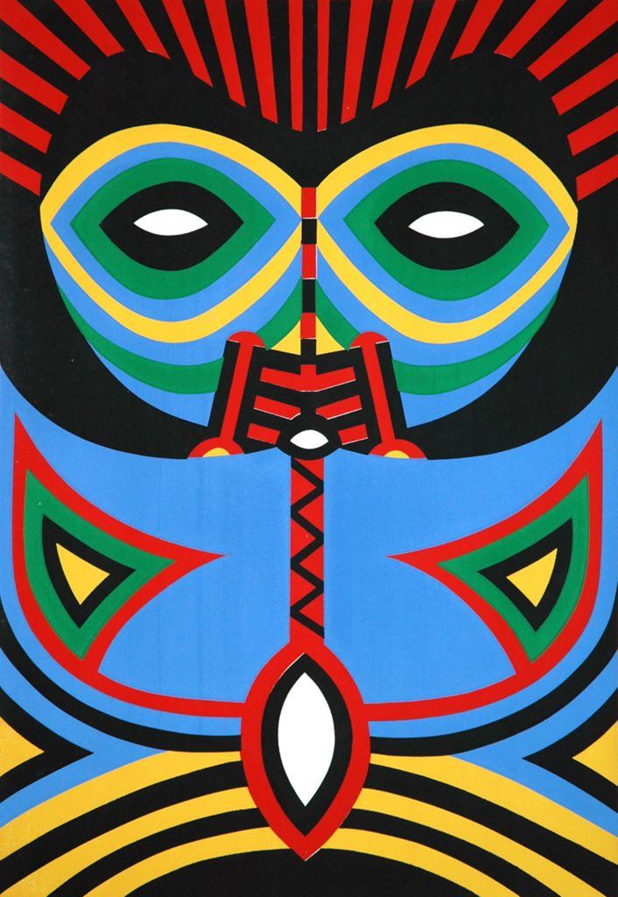 | Pacita Abad. Bacongo (Red and Blue). 1983. Private collection.
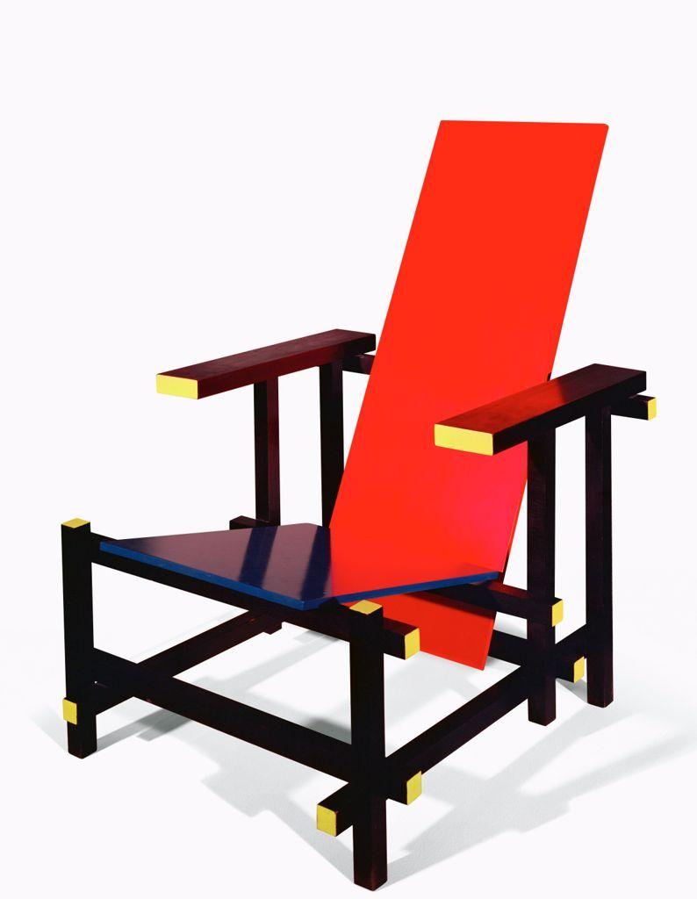 | Gerrit Thomas Rietveld. Armchair Red and Blue. 1918. Stedelijk Museum.
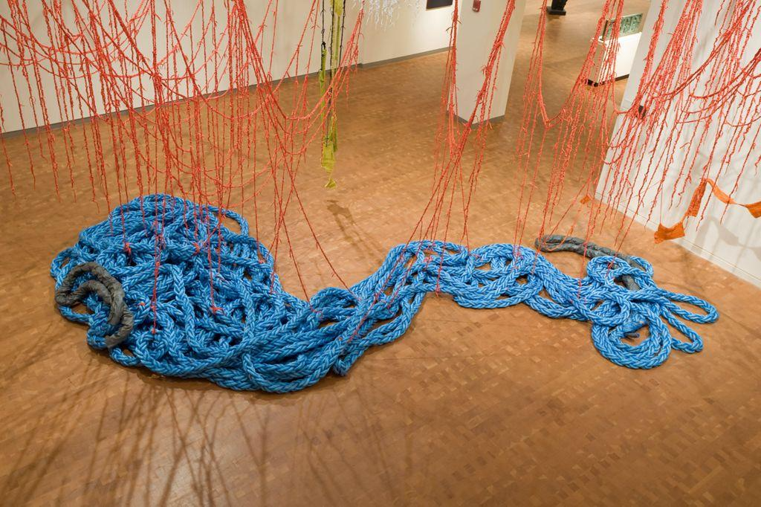 | Sheila Pepe. Red Hook at Bedford Terrace. 2008. Smith College Museum of Art.
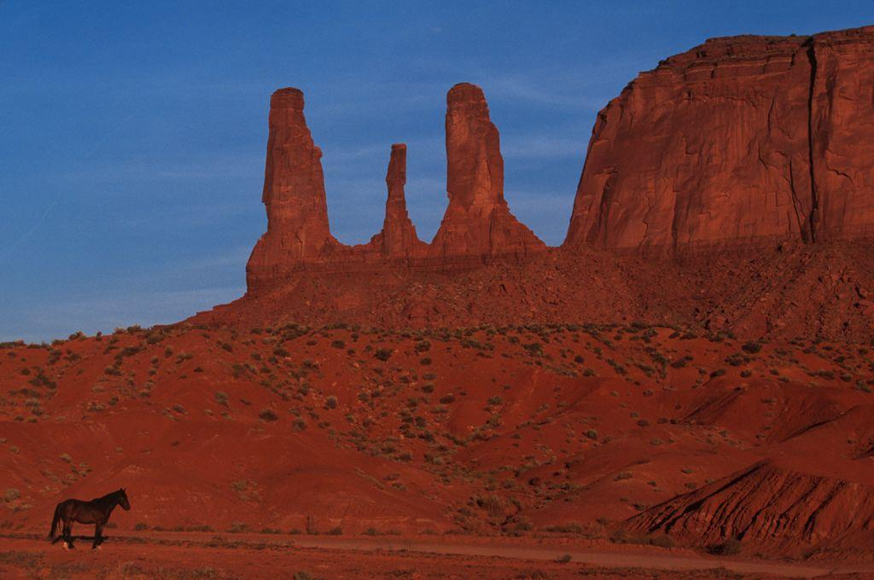 | Thomas Hoepker. USA. Arizona. Monument Valley. 1995. Magnum Photos.
 | Dan Flavin. Untitled. ca. 1970. RISD Museum.
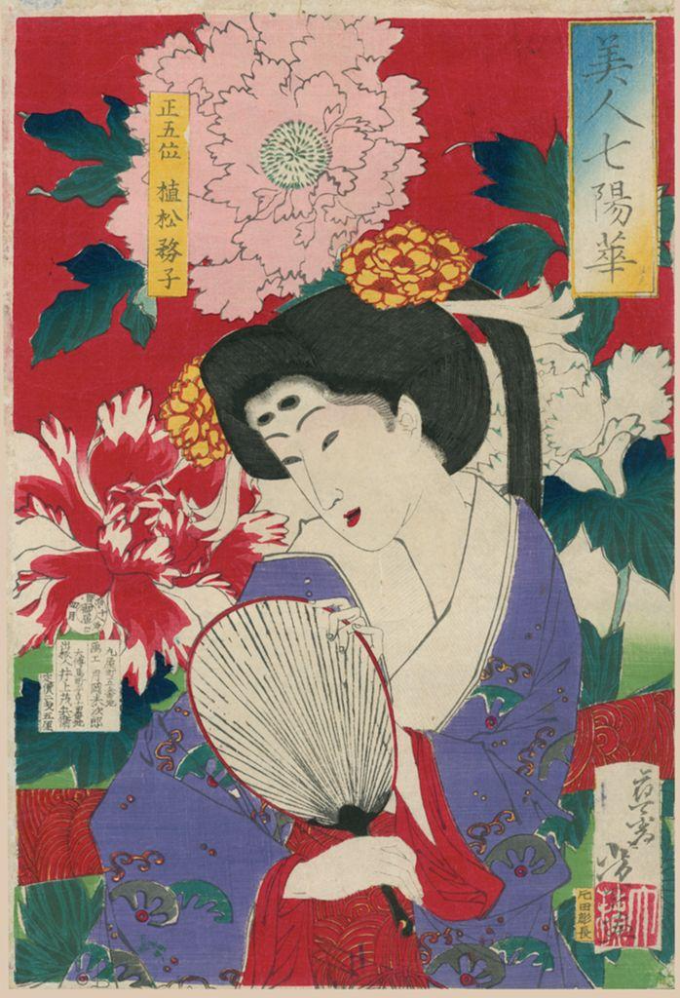 | Tsukioka Yoshitoshi. Beauties and the Seven Bright Flowers: Peony, Uematsu Chikako. 1878. Ruth Chandler Williamson Gallery, Scripps College.
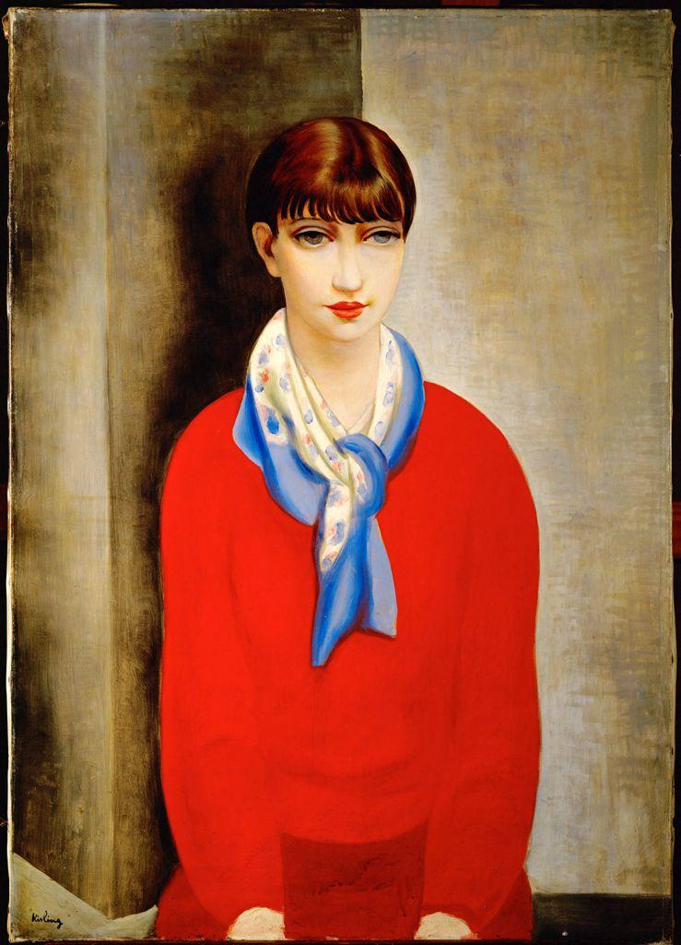 | Moïse Kisling. Kiki de Montparnasse (with Red Sweater and Blue Scarf). 1925. Petit Palais (Geneva, Switzerland).
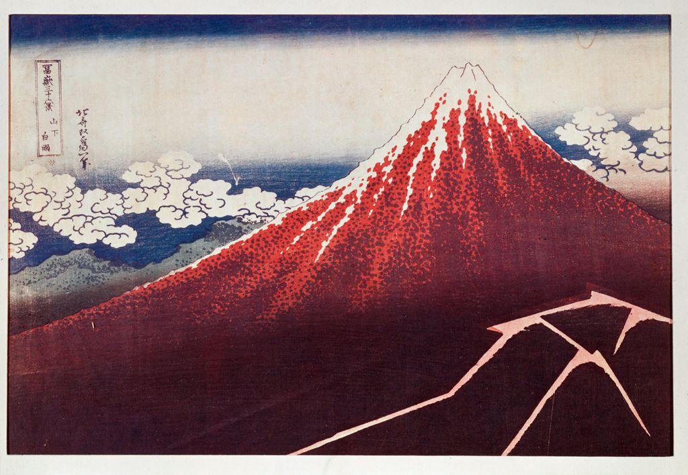 | Katsushika Hokusai. Lightning on Mount Fuji, from the Series “36 Views of Mount Fuji.” c. 1823. Musée Guimet, Paris, France.
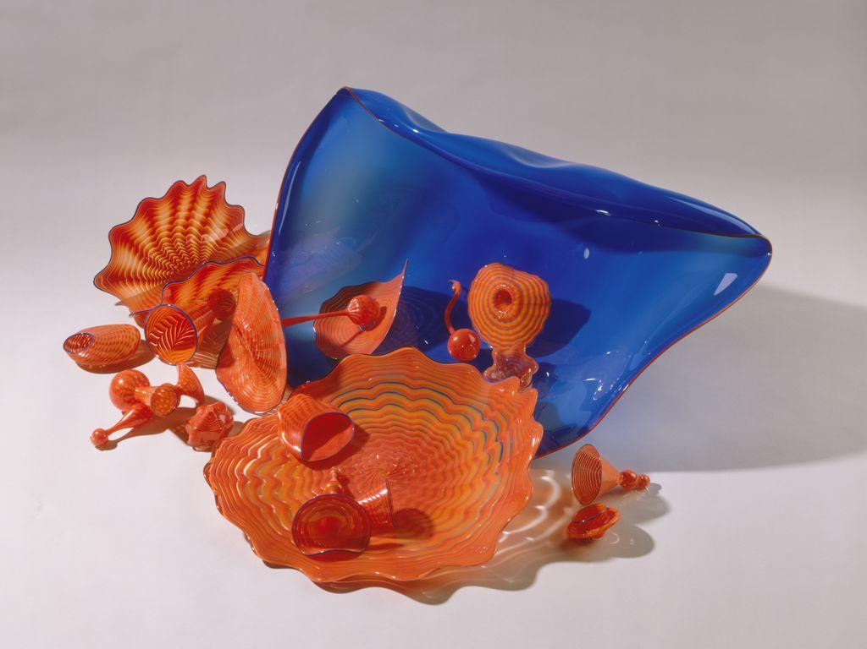 | Dale Chihuly. Blue-Stemmed Form with Orange and Red Persians, from the “Persian” Series. 1988. Seattle Art Museum.
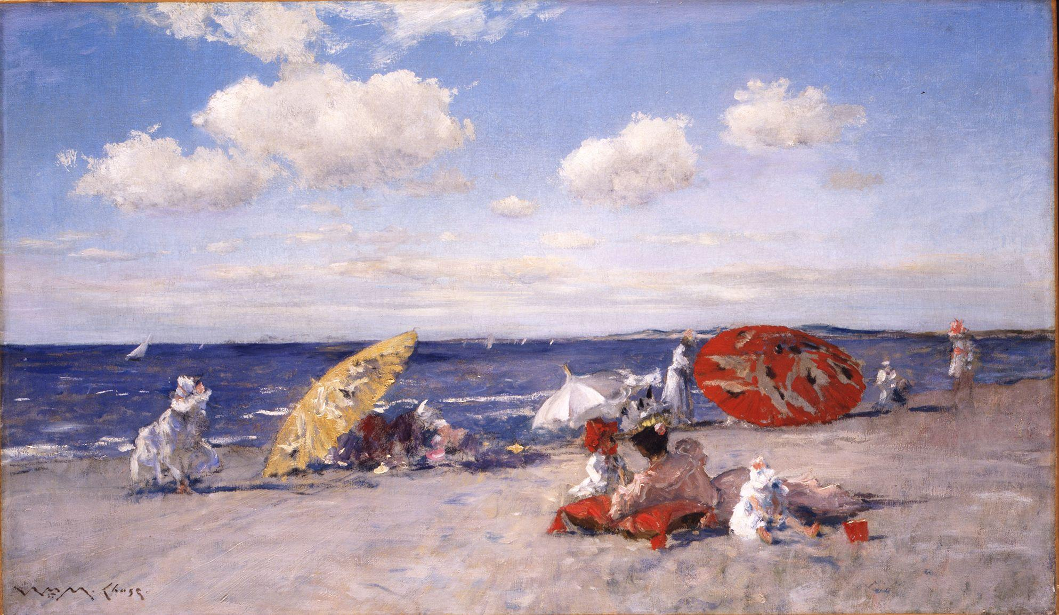 | William Merritt Chase. At the Seaside. ca. 1892. The Metropolitan Museum of Art.
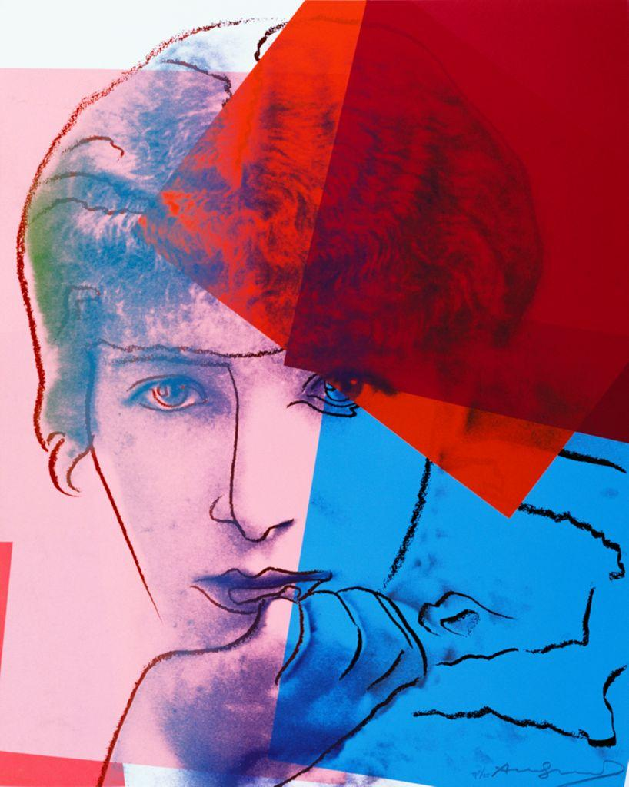 | Andy Warhol. Ten Portraits of Jews of the Twentieth Century: Sarah Bernhardt. 1980. The Andy Warhol Foundation for the Visual Arts, Inc.
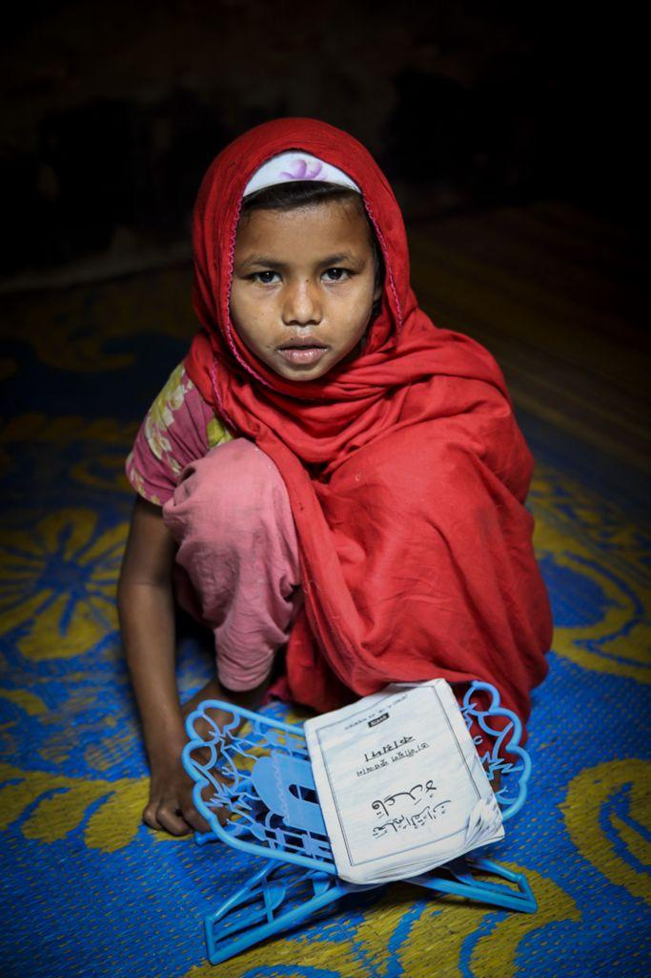 | G.M.B. Akash. A Young Girl Reading a Religious Text. n.d. Panos Pictures.
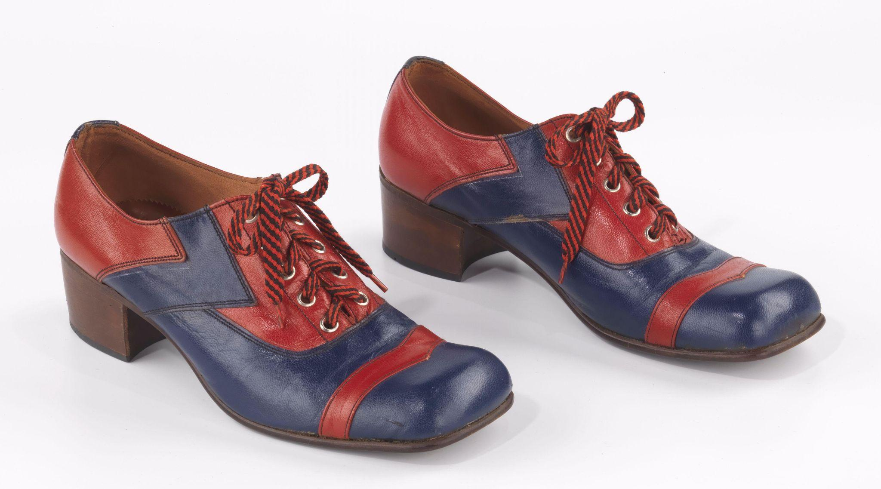 | John Hardy (Designer and manufacturer). Day Shoes (Oxfords). 1975. The Metropolitan Museum of Art.
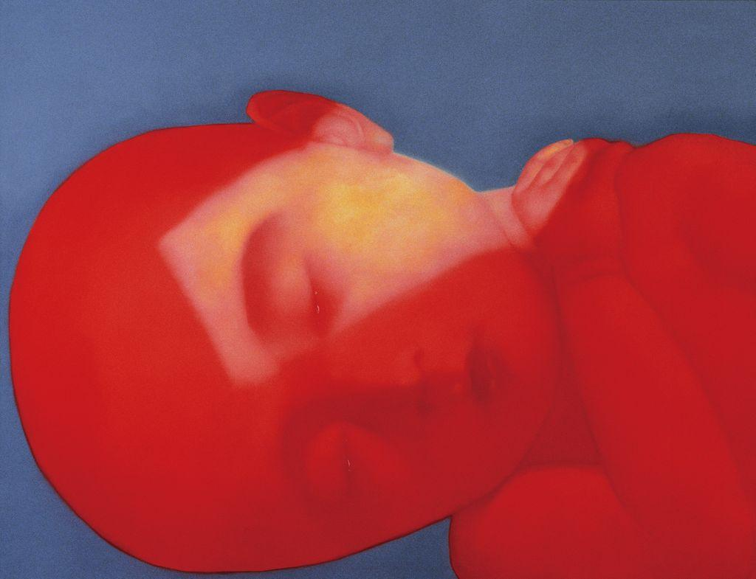 | Xiaogang Zhang. Red Baby. 2005. Asia Art Archive.
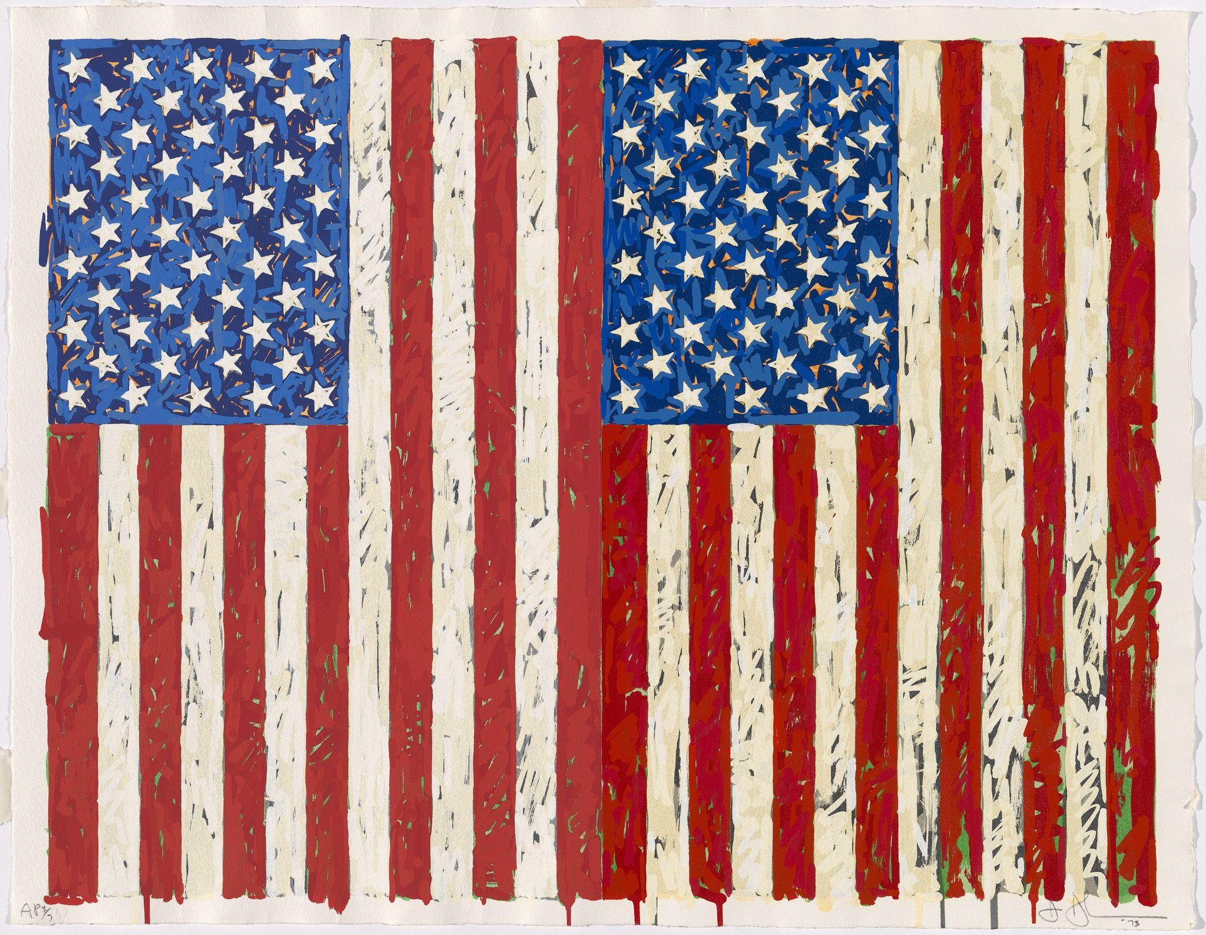 | Jasper Johns. Flags I. 1973. The National Gallery of Art (Washington, D.C.).
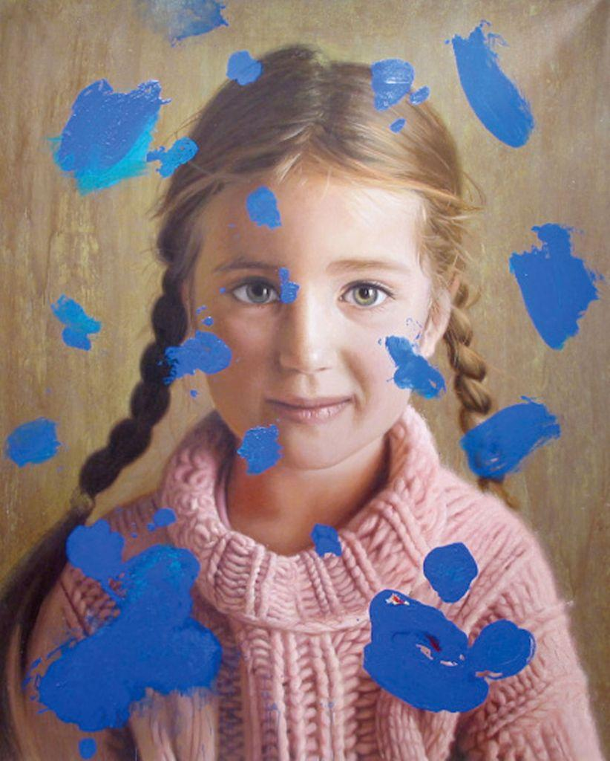 | Lino Lago. Girl with Blue Paint. 2010. Flint Institute of Arts.
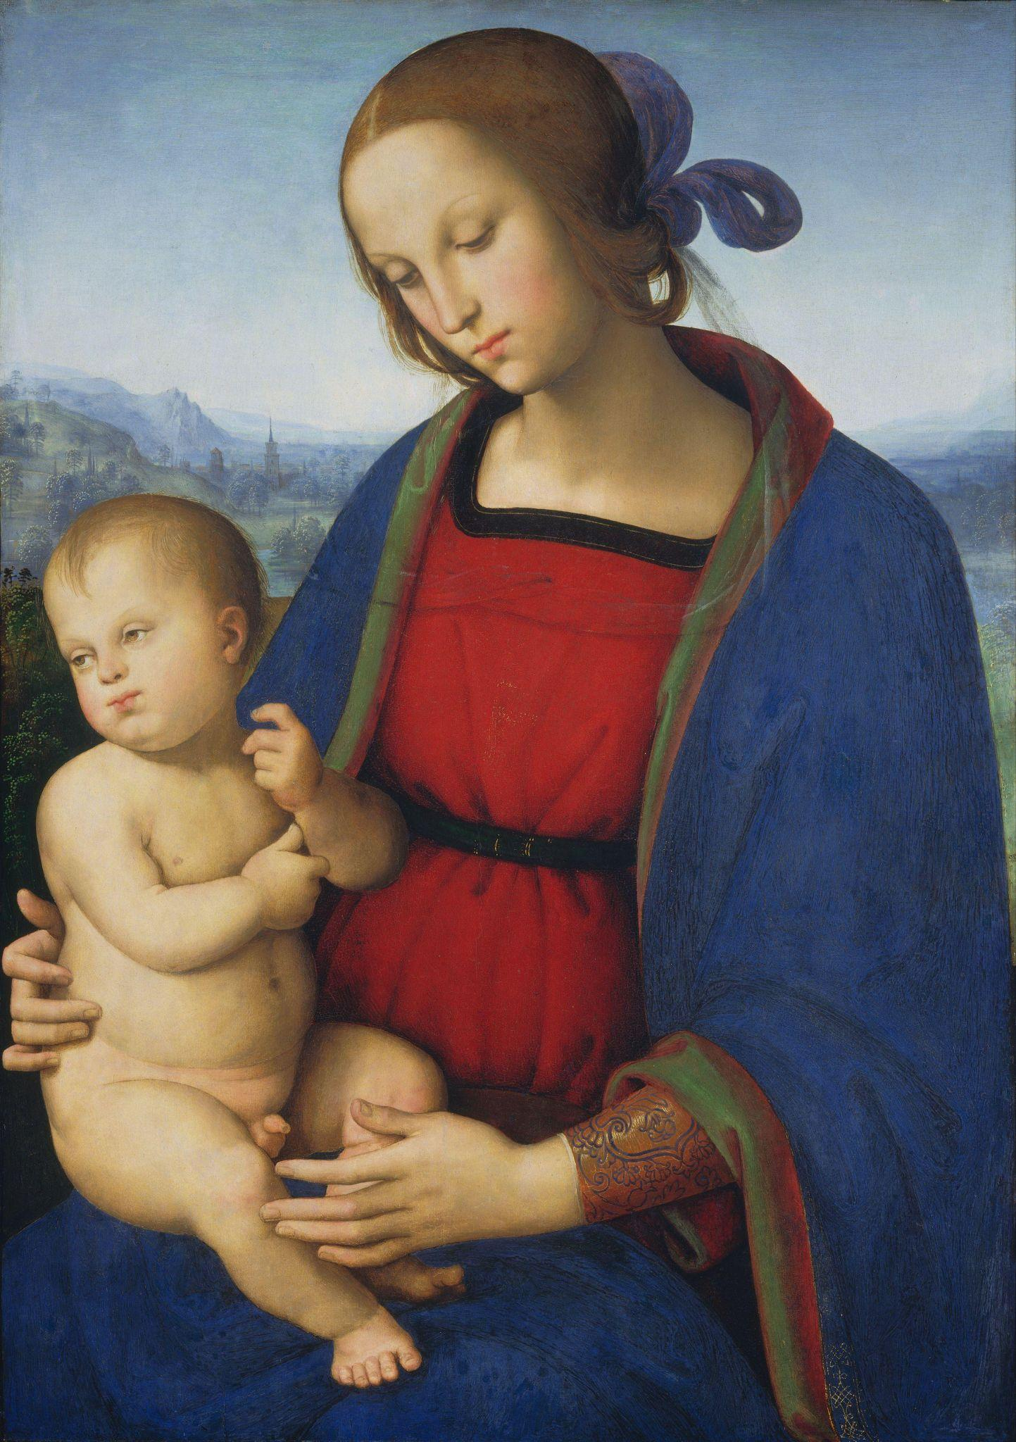 | Pietro Perugino. Madonna and Child. c. 1500. The National Gallery of Art (Washington, D.C.).
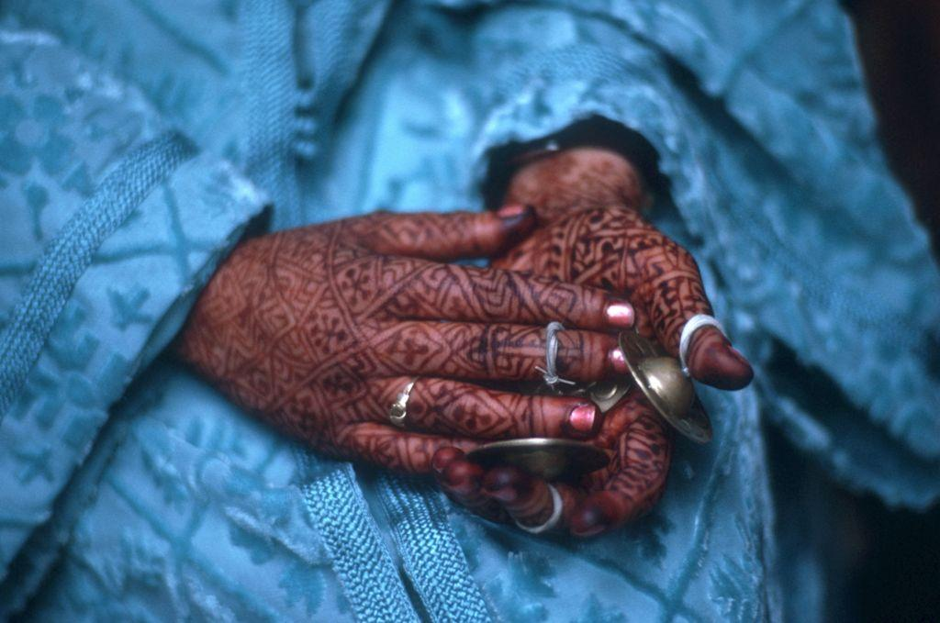 | Burt Glinn. MORROCO. Marrakesh. 1971. The Tattooed Hands of a Berber Woman in Her Traditional Party Clothes. 1971. Magnum Photos.

